Report

Data Processing

The style image is resized to the same dimension as the content image

Content and Style Image Visualization

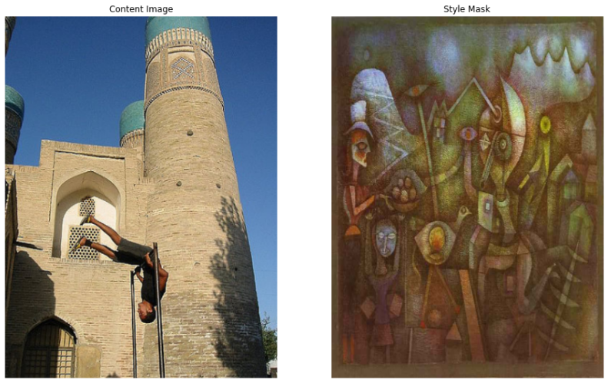

Model Architecture (VGG19)

----------------------------------------------------------------

Layer (type) Output Shape Param #

================================================================

Conv2d-1 [-1, 64, 224, 224] 1,792

ReLU-2 [-1, 64, 224, 224] 0

Conv2d-3 [-1, 64, 224, 224] 36,928

ReLU-4 [-1, 64, 224, 224] 0

MaxPool2d-5 [-1, 64, 112, 112] 0

Conv2d-6 [-1, 128, 112, 112] 73,856

ReLU-7 [-1, 128, 112, 112] 0

Conv2d-8 [-1, 128, 112, 112] 147,584

ReLU-9 [-1, 128, 112, 112] 0

MaxPool2d-10 [-1, 128, 56, 56] 0

Conv2d-11 [-1, 256, 56, 56] 295,168

ReLU-12 [-1, 256, 56, 56] 0

Conv2d-13 [-1, 256, 56, 56] 590,080

ReLU-14 [-1, 256, 56, 56] 0

Conv2d-15 [-1, 256, 56, 56] 590,080

ReLU-16 [-1, 256, 56, 56] 0

Conv2d-17 [-1, 256, 56, 56] 590,080

ReLU-18 [-1, 256, 56, 56] 0

MaxPool2d-19 [-1, 256, 28, 28] 0

Conv2d-20 [-1, 512, 28, 28] 1,180,160

ReLU-21 [-1, 512, 28, 28] 0

Conv2d-22 [-1, 512, 28, 28] 2,359,808

ReLU-23 [-1, 512, 28, 28] 0

Conv2d-24 [-1, 512, 28, 28] 2,359,808

ReLU-25 [-1, 512, 28, 28] 0

Conv2d-26 [-1, 512, 28, 28] 2,359,808

ReLU-27 [-1, 512, 28, 28] 0

MaxPool2d-28 [-1, 512, 14, 14] 0

Conv2d-29 [-1, 512, 14, 14] 2,359,808

ReLU-30 [-1, 512, 14, 14] 0

Conv2d-31 [-1, 512, 14, 14] 2,359,808

ReLU-32 [-1, 512, 14, 14] 0

Conv2d-33 [-1, 512, 14, 14] 2,359,808

ReLU-34 [-1, 512, 14, 14] 0

Conv2d-35 [-1, 512, 14, 14] 2,359,808

ReLU-36 [-1, 512, 14, 14] 0

MaxPool2d-37 [-1, 512, 7, 7] 0

AdaptiveAvgPool2d-38 [-1, 512, 7, 7] 0

Linear-39 [-1, 4096] 102,764,544

ReLU-40 [-1, 4096] 0

Dropout-41 [-1, 4096] 0

Linear-42 [-1, 4096] 16,781,312

ReLU-43 [-1, 4096] 0

Dropout-44 [-1, 4096] 0

Linear-45 [-1, 1000] 4,097,000

VGG-46 [-1, 1000] 0

================================================================

Total params: 143,667,240

Trainable params: 0

Non-trainable params: 143,667,240

----------------------------------------------------------------

Input size (MB): 0.57

Forward/backward pass size (MB): 238.69

Params size (MB): 548.05

Estimated Total Size (MB): 787.32

----------------------------------------------------------------

Loss

The project uses LBFGS loss function.

Optimization

Step=50 (Style Loss: 31.2526 Content Loss: 14.6364)

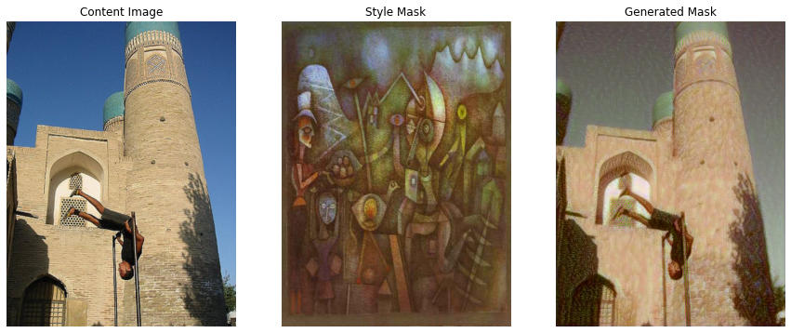

Step=100 (Style Loss: 16.7732 Content Loss: 10.2682)

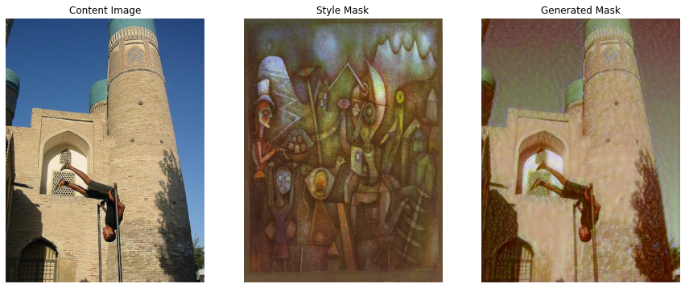

Step=150 (Style Loss: 8.6426 Content Loss: 8.5694)

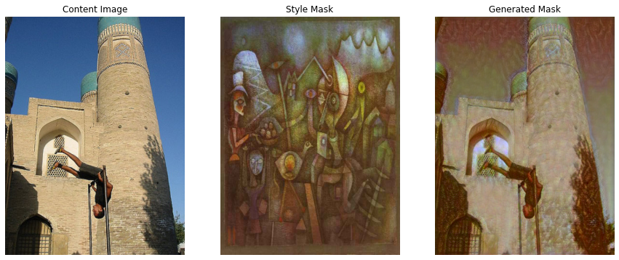

Step=200 (Style Loss: 4.6380 Content Loss: 7.4890)

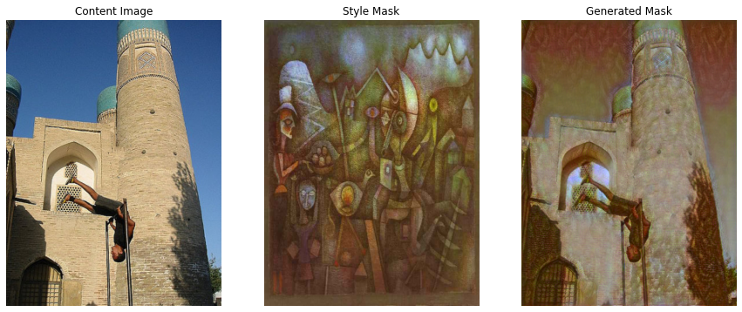

Step=250 (Style Loss: 2.2793 Content Loss: 6.7302)

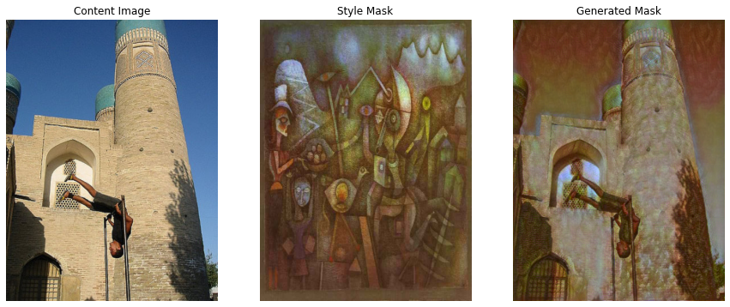

Step=300 (Style Loss: 1.1848 Content Loss: 6.1770)

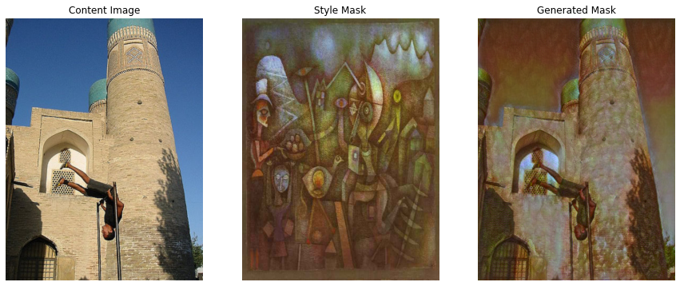

Results

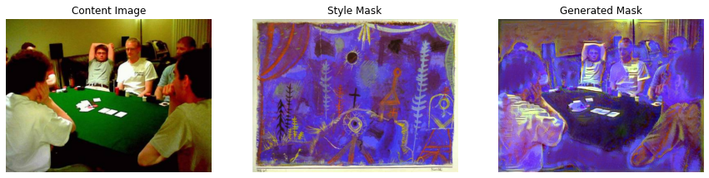



GUI

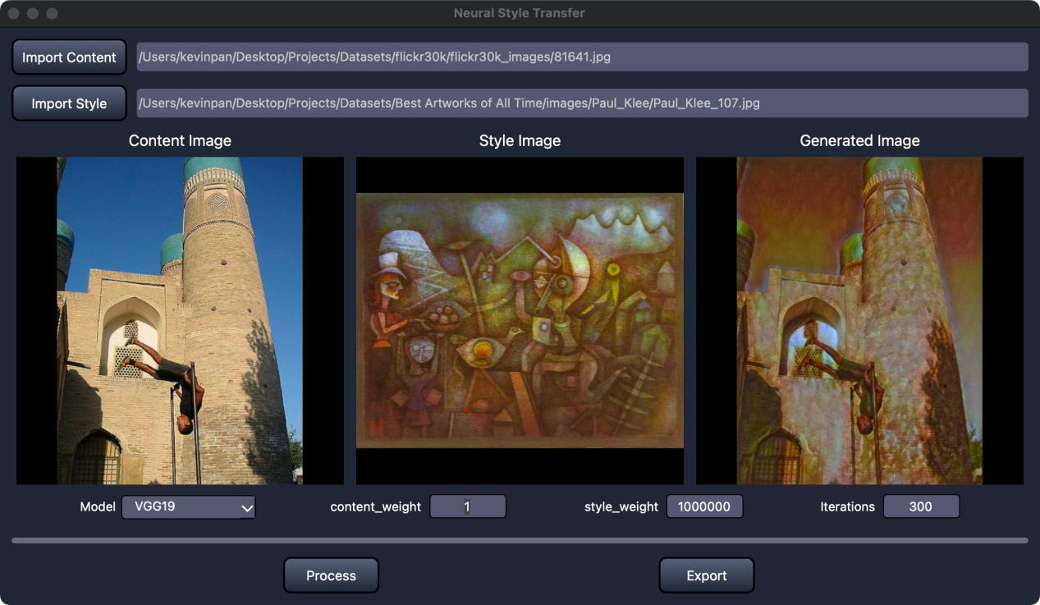

User Manual:

1. Press “Import content” button to load a content image.
2. Press “Import style” button to load a style image.
3. The Dropdown Model menu lets you pick which model to use.
4. content_weight, style_weight are the loss hyperparameters.
5. iterations lets you to choose the number of iteration to update the generated image.
6. Then press “Process” button to calculate the generated image.
7. Press the “Export” button to export the generated image.